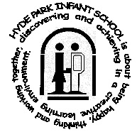



Friday 22nd May
^{th} May 2026
CONTACT US ON |   01752 225314 |   http://hydepark-inf.plymouth.sch.uk/  http://www.hydeparkjuniorschool.co.uk |   office@hydeparkprimary.co.uk
Latest News

Dear Parents, Guardians, and Carers,
As we reach the end of another busy and rewarding term, it feels like the perfect moment to pause, reflect, and celebrate all that has been achieved across our school community. It has been a term filled with enthusiasm, perseverance, and countless moments of pride, and we would like to take this opportunity to thank each and every one of you for your continued support. Together, we are building confident, capable learners who are ready to embrace new challenges both within and beyond the classroom.
This week has provided exciting enrichment opportunities across the school, particularly in Key Stage One. Our Year 1 and Year 2 pupils have engaged in thoughtful and meaningful learning linked to different religions. Through these activities, the children have developed a deeper understanding of the world around them, as well as an appreciation for diversity. This work supports one of our core British values—tolerance—and it has been inspiring to see the children demonstrate respect, curiosity, and empathy in their discussions and activities.
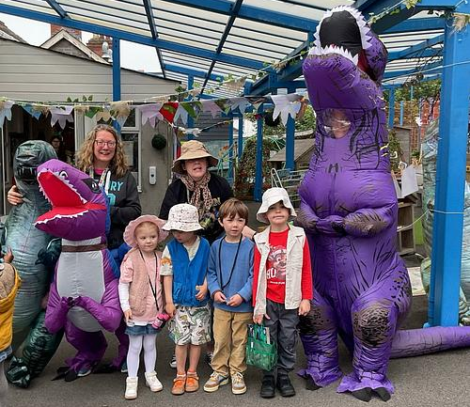
Reception have thoroughly enjoyed their enrichment week, with “Dinosaur Day” proving to be a particular highlight! Experiences like these not only bring learning to life but also help to build confidence, communication skills, and a love of discovery. Well done to our Reception team for creating such engaging and memorable experiences for our youngest learners.
A special thank you must also go to our dedicated Year 3 team as their swimming sessions come to an end. Over the past weeks, the children have shown determination, resilience and growing confidence in the water. Learning to swim is not only an essential life skill but an especially important one for our children, given our close proximity to the seaside.
Across the school, we have also been incredibly impressed with the progress in writing this term. The children have been applying their writing tool kits with increasing independence, producing work of a very high standard. It has been fantastic to see improved vocabulary, stronger sentence structures, and greater attention to detail. Most importantly, children are writing with purpose and pride, which is a significant achievement. We look forward to seeing this continue to grow next term.

We would also like to extend our sincere thanks to Mrs Moran, our Director of Education, for her invaluable support over the past few months. Her guidance, encouragement, and expertise have been greatly appreciated by staff and have had a positive impact on the continued development of our school. It has been a pleasure to work alongside her, and we are grateful for the time and commitment she has given to our community.
As the term concludes, we would like to remind you that school will be closed next week for the holiday. We hope this provides families with a chance to rest, spend time together, and enjoy a well-deserved break. We look forward to welcoming everyone back on 1st June, ready for the final half term of the academic year, which promises to be just as exciting and successful.
Finally, W would like to wish all our families a happy, safe, and relaxing holiday. Thank you once again for your continued support—it truly makes a difference.

This Week in Our Classrooms

Reception

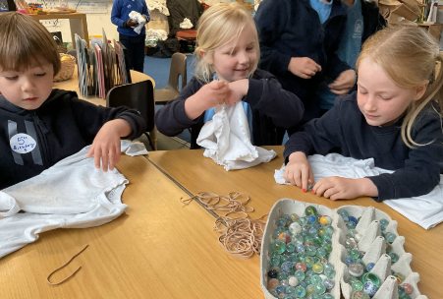
The children have enjoyed a wonderful week of experiences. They created vibrant tie‑dyed tops, made possible by a generous parent donation ensuring everyone participated. They enjoyed a visit from Wembury, learning about rock pools, and had great fun decorating biscuits. In the sunshine, they visited the park, joined by volunteers, and even enjoyed delicious pancakes together on the day.

Year 1

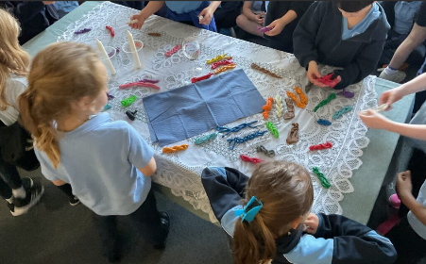
In R.E, we laid a Shabbat table together. We thought about how Jewish families bring in Shabbat and which senses we may use, such as smelling and tasting the bread, seeing the candles and hearing the music. We made some challah bread out of plasticine to show preparing the food for Shabbat.

Year 2

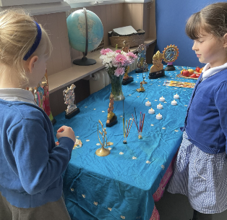
In RE, children have been learning about Hinduism, exploring how worship feels in a mandir and at a home altar. Using their senses, they imagined sights such as colourful deities, sounds of bells and prayers, the feel of smooth statues, the taste of prasad, and the rich scents of incense and flowers. This deepened their understanding of Hindu worship practices.

Year 3
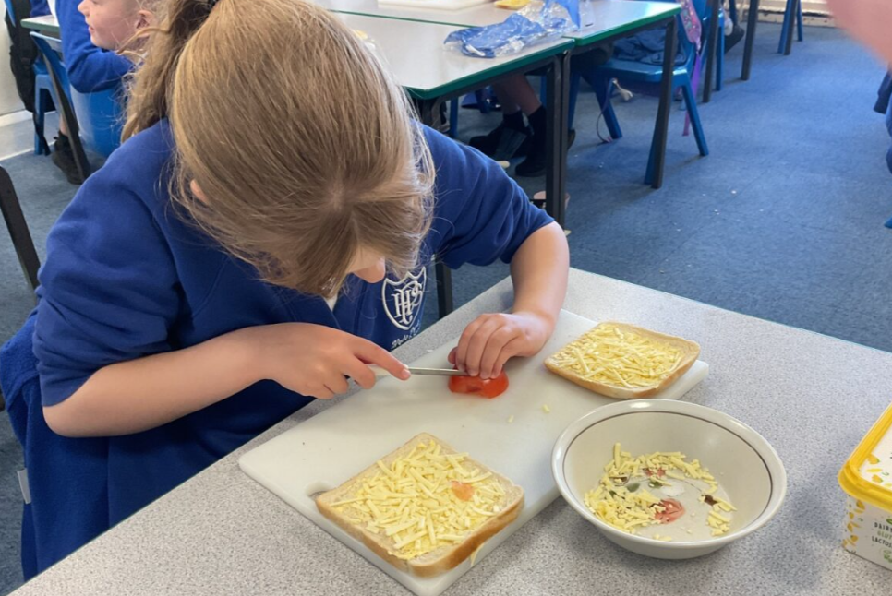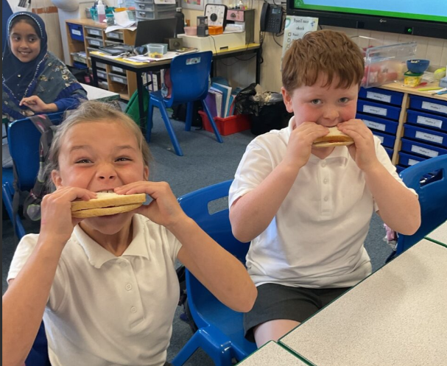
In DT this term we have been learning all about sandwiches. We have made our own bread rolls and then made our own sandwiches and wraps with a variety of fillings. Whilst making our sandwiches we learnt how to safely use a sharp knife to slice ingredients and how to butter bread.

Year 4
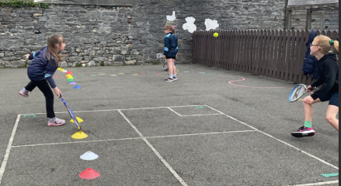
In PE, Year 4 have thoroughly enjoyed learning tennis. They have worked hard to improve their control, showing increasing accuracy when hitting the ball. Pupils are beginning to sustain good rallies with partners, demonstrating perseverance and teamwork. It has been wonderful to see their confidence grow as they apply new skills in games and challenges.

Year 5
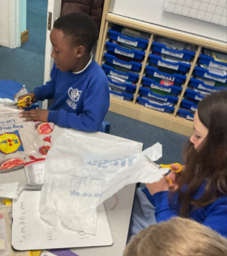
This week in science, we explored the forces of air and water resistance. We designed and tested parachutes with different surface areas to investigate how surface area affects air resistance. We discovered that the larger parachutes created more air resistance, causing them to fall slower.

Year 6
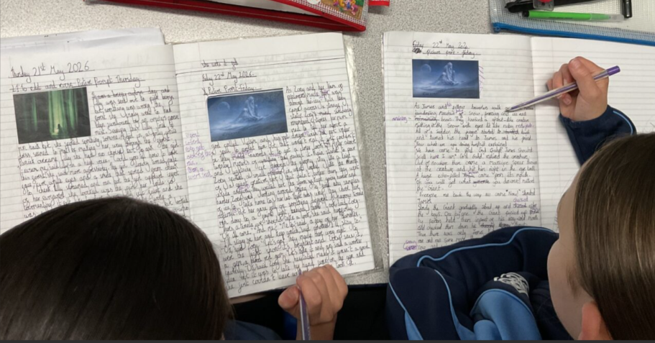
This week, Year 6 have been developing their writing skills using a picture prompt. The children produced some wonderful atmospheric pieces, carefully choosing their words to create mood and engage the reader. They focused on vocabulary, sentence structure and descriptive detail, showing real improvement and creativity, with many pupils confidently experimenting with language to enhance their imaginative writing even more.
In the news this Week
Each week in assembly, we explore a current news story and reflect on how it links to British Values, the UN Rights of the Child and protected characteristics, using questioning to support children in developing their oracy skills through thoughtful discussion.

Last weekend, football teams Manchester City and Chelsea competed in the Men’s FA Cup Final at Wembley Stadium. The FA (Football Association) Cup is one of the oldest football competitions in the world, with teams from across England and Wales taking part each year. Millions of people watched the match, supporting their teams and hoping to see them win the famous trophy. For the players, reaching the final is a huge achievement after months of hard work.
Things to talk about at home …
- Can you think of a time when you won something – what did you learn?
- What about a time you didn’t win – what did that teach you?
- In your opinion, why do some people keep trying even after losing?
- Talk together about how you believe we should behave when you lose.
Celebrating Achievement

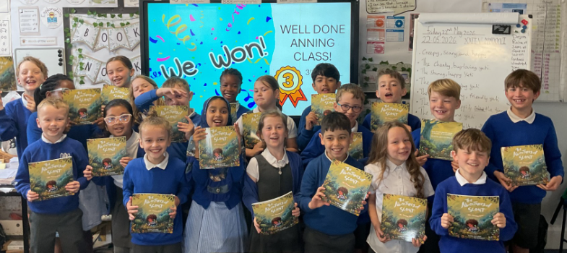
Together, we made a 'Bee Spa Hotel' - complete with 'bedrooms', a 'bee-cuzi' and a restaurant for tired bees to reenergise by drinking sugar water.
Some of us brought in recyclable items that we could use to create it, some people made their own bee baths at home (one child even brought it in filled with water, how they managed to keep it in there is a mystery to me!). Some children made decorations to stick to the hotel, with one child bringing in a beautiful bee that they had painted at home.
Other children decided that they wanted to design the individual rooms, one girl created a 'bee-auty parlour & fashion house' where they can buy clothes made of petals and smell natural floral scented perfume! Others created blueprints for the hotel and its individual rooms.
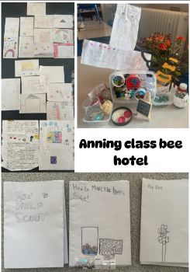
Some of us designed posters to show out support for Scout, and some of use created booklets to help show people what they can do to support her too. Finally, some children decided to do some in-depth research into bees and their habitats and needs, which was really exciting to read.
Our hard work paid off, and whilst we didn't win a trip to the farm, we did come in third place and each won a Scout book.
Well done Anning Class!!!
Remember
We love celebrating all the amazing activities our pupils get up to outside of school, If your child is involved in any kind of hobby or activity, please send a short description and a picture of them in action to the admin team.
Please remember: We cannot publish any photos that include other children. If you send in a photo, please make sure only your child is visible.
Thank you for your help in celebrating all of our stars!

Golden Ticket Success! 🎉📚
We are delighted to celebrate this term’s Golden Ticket Prize Draw winners – a huge congratulations to all of our lucky pupils who were drawn! Your enthusiasm and commitment to reading is truly inspiring.
An extra special well done goes to every single pupil who earned a Golden Ticket this term. By reading regularly and successfully passing your Accelerated Reader quizzes, you have shown fantastic dedication, perseverance, and a real love of books. Each ticket represents a brilliant achievement, and we couldn’t be prouder of you all.
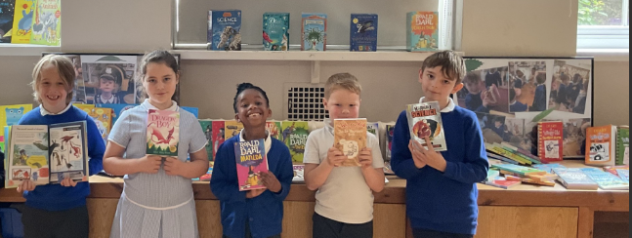
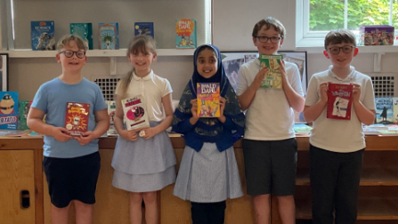
Keep up the amazing reading—who will be our next Golden Ticket winners? 🌟📖

Accelerated Reader: Supporting a Love of Reading at Our School
At our school, reading is at the heart of everything we do. We believe that developing strong reading habits not only supports academic success but also nurtures curiosity, imagination and confidence. Reading opens doors to new worlds, builds vocabulary and helps children make sense of the world around them. One of the key ways we encourage this is through our use of Accelerated Reader (AR), a programme designed to motivate children and support their reading development in a structured and engaging way.
Accelerated Reader helps children choose books that are appropriately matched to their reading ability. Each child has a level or range which ensures that the books they select are neither too easy nor too difficult. This balance is important because it allows children to experience success while still being challenged. When children are reading books that suit their ability, they are far more likely to enjoy reading and develop confidence as independent readers.
After finishing a book, children take a short quiz on the Accelerated Reader system. These quizzes assess how well they have understood what they have read, focusing on key details, vocabulary and comprehension skills. This means that reading is not just about getting through a book, but about truly understanding and engaging with it. Teachers use the information from these quizzes to monitor progress, celebrate success and provide targeted support where needed.
We have clear and consistent expectations for all of our pupils. Children are expected to read regularly at home and in school, and to complete at least one Accelerated Reader quiz every week (unless a longer novel) . Weekly quizzing encourages children to stay focused, finish their books and take ownership of their learning.
To further motivate and reward our readers, we celebrate success through our Dojos and our Golden Ticket system. Children who score 80% or higher on their quiz earn a Golden Ticket. These tickets recognise not only effort but also strong comprehension and engagement with the text. Collecting Golden Tickets is something children are extremely proud of, and it helps to create a positive reading culture across the school. It encourages children to think carefully about the books they choose and to take their time when reading, rather than rushing through texts.
We recognise that parents and carers play a vital role in developing a child’s love of reading. Your support at home is incredibly important. Listening to your child read, encouraging them to read regularly, asking questions about their book and celebrating their achievements all make a significant difference. Please also remember to sign your child’s reading log each time they read at home, as this helps us track their progress and celebrate their commitment to reading. Even small daily reading habits can have a huge impact over time.
We are incredibly proud of the enthusiasm our children show for reading and the progress they make. By working together—school and home—we can foster a lifelong love of reading and ensure every child develops the skills they need to succeed, both now and in the future.

Competition Time
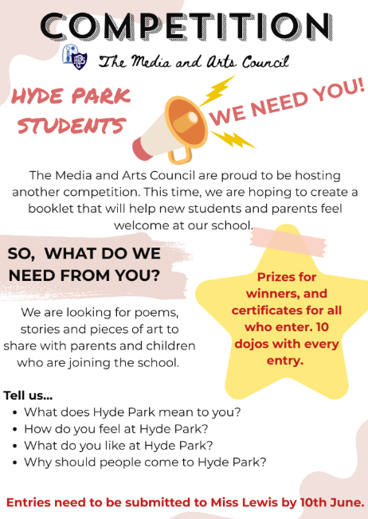

Nominations for being a Curious Learner

Keller | Keller Class
Nightingale | Yahya
Potter | Aiden
Rosen | Tommy A
Astor | Margot
Coleman | Kaelyn
Pankhurst | Teyoni
Scott | Harlin
Attenborough
Anning | Tom
Curie | Forrest
Turing | Flora
Hawking | Harrison
Gandhi | Jackson
Mandela | Abel
Tubman | Coco
Douglass | Anna
King | Archie
Seacole | Jack

May 22nd 2026
Keller | Keller Class
Nightingale | Ivor T
Potter | Zayd
Rosen | Poppy
Astor
Coleman | Jimmy
Pankhurst | Ollie
Scott | Teddy
Attenborough
Anning | Eleri
Curie | Rafe
Turing | Leo
Hawking | Clara
Gandhi | Luciana
Mandela | Tawsif
Tubman | Maisie
Douglass | Kitty
King | Freddie
Seacole | Esther-Rose

